**EXPERIMENT-1**

**CONFIGURATION OF NETWORK COMPONENTS**

**Aim:** To Study the following Network Devices in Detail

* PC
* Server
* Repeater
* Hub
* Switch
* Bridge
* Router
* Gate Way
* Transmission medium

**Apparatus (Software): CISCO Packet tracer**.

**1 Node:** In a communications ***network***, a ***network node*** is a connection point that can

receive, create, store or send data along distributed ***network*** routes.

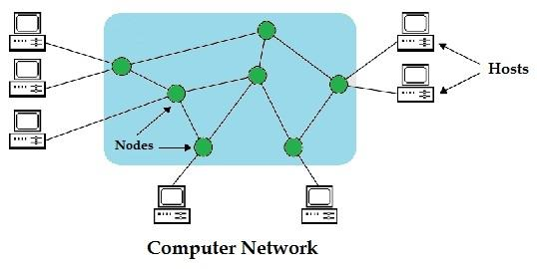

2. **Repeater:** Functioning at Physical Layer.

A **repeater** is an electronic device that receives a signal and retransmits it at a

higher level and/or higher power, or onto the other side of an obstruction, so that

the signal can cover longer distances.

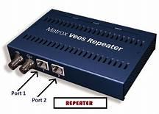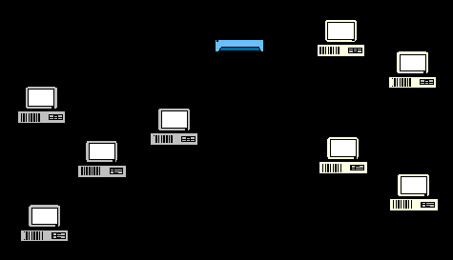

**3. Hub: Ethernet hub**, **active hub**, **network hub**, **repeater hub**

Hub or concentrator is a device for connecting multiple twisted pair or fiber optic

Ethernet devices together and making them act as a single network segment. Hubs work

at the physical layer (layer 1) of the OSI model. The device is a form of multiport

repeater. Repeater hubs also participate in collision detection, forwarding a jam signal

to all ports if it detects a collision.

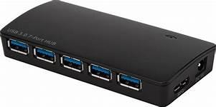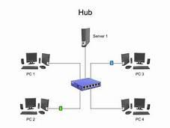

**4. Switch: A network switch or switching hub** is a computer networking device that

connects network segments. The term commonly refers to a network bridge that

processes and routes data at the data link layer (layer 2) of the OSI model. Switches

that additionally process data at the network layer (layer 3 and above) are often

referred to as Layer 3 switches or multilayer switches.

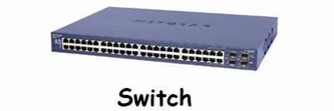

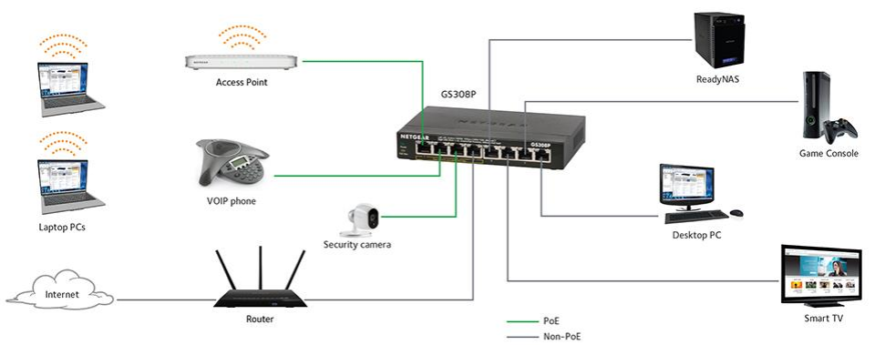

5. **Bridge:** A **network bridge** connects multiple network segments at the data link

layer (Layer 2) of the OSI model. In Ethernet networks, the term bridge formally means

a device that behaves according to the IEEE 802.1D standard. A bridge and switch are

very much alike; a switch being a bridge with numerous ports. Switch or Layer 2 switch

is often used interchangeably with bridge. Bridges can analyze incoming data packets

to determine if the bridge is able to send the given packet to another segment of the

network.

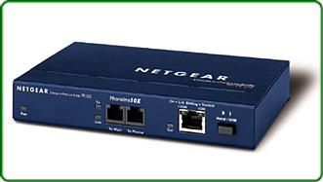

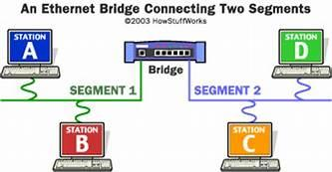

6. **Router:** A **router** is an electronic device that interconnects two or more computer networks, and selectively interchanges packets of data between them. Each data packet

contains address information that a router can use to determine if the source and

destination are on the same network, or if the data packet must be transferred from one

network to another. The multiple routers are used in a large collection of interconnected

networks, the routers exchange information about target system addresses, so that each

router can build up a table showing the preferred paths between any two systems on the

interconnected networks.

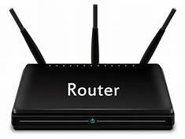

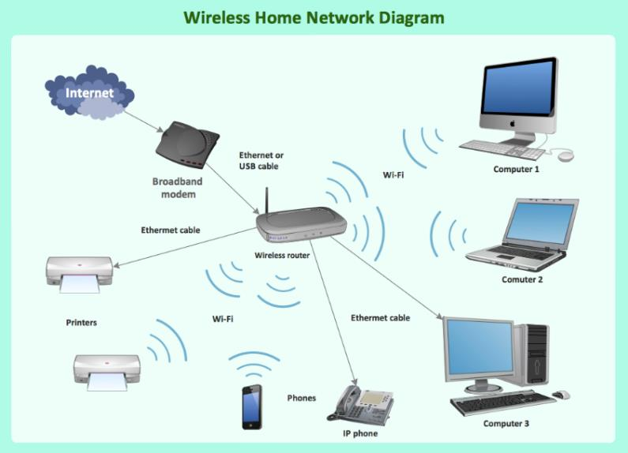

7. **Gate Way:** In a communication network, a network node equipped for interfacing with

another network that uses different protocols. A gateway may contain devices such as

protocol translators, impedance matching devices, rate converters, fault isolators, or

signal translators as necessary to provide system interoperability. It also requires the

establishment of mutually acceptable administrative procedures between both networks.

• A protocol translation/mapping gateway interconnects networks with

different network protocol technologies by performing the required

protocol conversions.

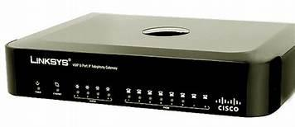

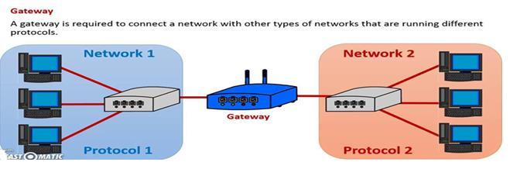

8. Server: A server is a type of computer or device on a network that manages

network resources. Servers are often dedicated, meaning that they perform no other tasks

besides their server tasks. On multiprocessing operating systems, however, a single

computer can execute several programs at once. A server in this case could refer to the

program that is managing resources rather than the entire computer.

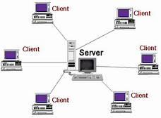

9. **Transmission media**: The medium through which the signals travel from one device to

another. These are classified as guided and unguided. Guided media are those that provide

a conduit from one device to another. Eg. Twisted pair, coaxial cable etc. Unguided media

transport signals without using physical cables. Eg. Air.

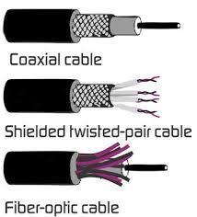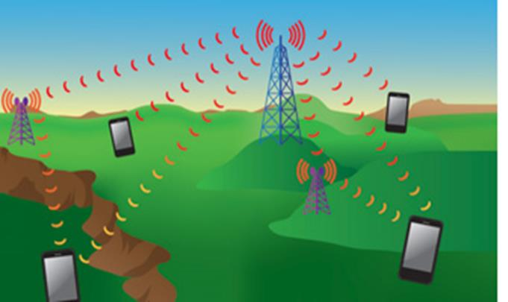

**Result:** Thus the network components are studied in detail.